**Project Name**: Right Resource Fit

**Description**: Right Resource Fit is designed to streamline recruitment processes, enabling the Human Resource Management Team to handle functions related to hiring efficiently.

**Purpose:**This project will enable the Human Resource Management Team to handle HR functions related to recruitment.

**Installation and Setup:**

**-Clone the repository:**

git clone <https://github.com/springboardmentor106/RightResourceFit_Infosys_Internship_Oct2024_Team_04.git>

**-Frontend Setup:**

cd Frontend\RRF

npm install

npm start

npm run dev

**-Backend Setup:**

cd backend

npm install

npx nodemon

**Folder Structure:**

- Frontend RRF - contains frontend code for UI components and pages.

- backend - contains backend code for user authentication, job posting, email verification, etc.

config - holds configuration and connection files.

models - defines database structure.

routes - contains API endpoints.

controllers - logic for handling request

**Key Features and Modules:**

- User Management: Signup, login, password reset, email link verification.

- Job Posting: Create, update, and delete job posts.

- Application Management: Track and manage job applications.

- Tracking of job status: Follow-up system for HR and job seekers.

- Administration: Admins analyze users and jobs and manages the application

**Project Components:**

HomePage: The landing page where users are introduced to the application and its main features.

Login: Allows users to log in with their credentials. Handles input validation and authentication requests.

Register: User registration page where new users can create an account. Manages form inputs and user data submission.

User/Admin Dashboard: After logging in, users are directed here to view their matched projects and apply for open positions.

Profile: Shows user information and allows users to update their profiles.

ApplicationForm: Allows users to submit an application for a project, collecting relevant information and documents.

Notification: Email verification link sent to email for password reset in notification page.

**API Documentation:**

Describe API endpoint:

- Signup:

- Endpoint:/api/user/

- Method: handleSubmit

- Description: Registers a new user as a job seeker or company.

- Login:

- Endpoint:/api/user/

- Method: handleSubmit

- Description: Authenticates the user and redirects to the homepage.

- Reset Password:

- Endpoint:/api/user/reset-password/

- Method: handleSubmit

- Description: Sends Email verification link for password reset verification.

**Front-end Documentation**

Key routes and components:

- Routes: LandingPage, About, Login, Register, ResetPassword, EmailVerification, User Dashboard,Admin Dashboard, Search for Companies and jobs

- UI Components: Detail how to use and customize the main UI components

**Error Handling and Troubleshooting**

Common errors and to troubleshoot them:

- Check if less secure app access is enabled for Gmail.

- Port Conflicts: Ensure no other services are running on port.

**API information:**

**Frontend:**

**1. User Registration API**

- Endpoint: `/api/user/register`

- Method: `POST`

- Request Body:

{

"name": "John Doe",

"email": "john.doe@gmail.com",

"password": "password123",

“Confirm password”:”password123”,

"phoneNumber": "1234567890”

}

- Response:

{

"success": true,

"message": "Registered successfully!",

}

**2. User Login API**

- Endpoint: `/api/user/login`

- Method: `POST`

- Request Body:

{

"email": "john.doe@gmail.com",

"password": "password123"

}

- Response:

{

"success": true,

"message": "Logged in successfully!",

}

**3. Password Reset Request API**

- Endpoint: `/api/user/reset-password/`

- Method: `POST`

- Request Body:

{

"email": "john.doe@gmail.com"

}"

- Response:

{

"success": true,

"message": "Password reset link sent to the registered email."

}

**4. Email Verification API**

- Endpoint: `/api/user/reset-password/`

- Method: `GET`

- Request Body:

{

"email": "john.doe@gmail.com"

}

- Response:

{

"success": true,

"message": "Password reset link sent!"

}

**5. Job Posting API (for Companies)**

- Endpoint: `/api/jobs/postings`

- Method: `POST`

- Request Body:

{

"title": "frontend developer",

"description": "We are looking for a skilled frontend developer to join our team.",

"location": "Delhi",

"salary": "40000-60000",

"skills": ["Angular", "React", "Node.js"],

“Employment type”:”Full-Time”,

“Working schedule”:”day shift”;

“Salary”:”custom”;

}

- Response:

{

"success": true,

"message": "Job posted successfully",

"

}

**6. View Job Listings API (for Job Seekers)**

- Endpoint: `/api/application?applicantID`

- Method: `GET`

- Response:

{

"success": true,

"jobs": [

{

"title": “frontend developer”,

"location": "Mumbai",

"salary": "60000-80000",

"skills": ["JavaScript", "Angular", "Node.js"]

“Employment type”:”Full-time”,

“Working schedule”:”Day shift”,

“Salary”:”2871 Custom(Monthly)”

},

{

"jobId": "job680",

"title": "Product Developer",

"company": "Infosys",

"location": "Hyderabad",

"salary": "80000-120000",

"requirements": ["Product Management", "Agile", "Leadership"]

“Employment type”:”Full-time”

“Working schedule”:”Day shift”,

“Salary”:”2871 Custom(Weekly)”

}

]

}

**7. Apply for a Job API (for Job Seekers)**

- Endpoint: `/api/application?applicantID=`

- Method: `POST`

- Request Body:

{

“Cover letter”:”brief cover letter”

"resume": "resume.pdf(download)"

}

- Response:

{

"success": true,

"message": "Application submitted successfully."

}

**8. View Application Status API (for Job Seekers)**

- Endpoint: `/api/application?applicantID`

- Method: `GET`

- Response:

{

"success": true,

"applications": [

{

"Position": "web developer",

"Date applied": "November 11,2024",

"status": "Reviewed"

},

{

"Position": "web developer",

"Date applied": "November 11,2024",

"status": "Applied

}

]

}

**9. Job Seeker Profile Update API**

- Endpoint: `/api/user/profile`

- Method: `PUT`

- Request Body:

{

"name": "John Doel",

"email": "john.doe@gmail.com",

"Phone number":”1234567890”,

}

- Response:

{

"success": true,

"message": "Profile updated successfully."

}

**10. Company Dashboard Status API**

- Endpoint: `/api/application`

- Method: `GET`

- Response:

{

"success": true,

"stats": {

"totalJobPostings": 8,

"applicationsReceived": 20,

"applicationsPendingReview": 14,

"Shortlisted applicants": 5

}

}

**Backend:**

**1.User Api:**

**Route Api :** ../controllers/userController

**Controller:** The **user controller** serves as the backbone of the user management system in the application. It facilitates actions like:

* Registering new users.
* Logging users in and authenticating them with JWT.
* Allowing users to update their profiles and reset passwords.
* Providing admin functionality to manage users (e.g., viewing, updating, deleting, restoring users).

Each function is tied to an HTTP endpoint and performs a specific user-related task, ensuring a structured flow of operations related to user management.

### **Features:**

* **JWT Authentication**: Many functions (like getUserProfile, updateUserProfile, etc.) rely on JWT tokens for authentication. The req.user.id comes from the token and ensures that the user is authenticated.
* **Nodemailer**: Used for sending emails, specifically for password reset functionality. SMTP connection details (like host, port, and credentials) are stored in environment variables.

**2.Upload Api:**

**Route Api:**../controllers/uploadController

**Controller:**The **uploadController** is designed to handle file uploads, specifically images and PDFs, and to upload them to Cloudinary. It:

* Validates the file.
* Determines the correct resource type (image or raw for PDFs).
* Uploads the file to Cloudinary.
* Returns the URL of the uploaded file to the client.

This controller allows users to upload files to the cloud with the added benefit of handling transformations and file type validation.

**3.Report Api:**

**Route Api:**../controllers/reportController

**Controller:**The **reportController** is responsible for managing user reports and dashboard data. It allows users to:

* Generate new reports and associate them with their account.
* Retrieve dashboard data that might include job postings, applications, and other related information.
* Retrieve a list of all reports associated with a specific user.

This controller provides a way for users to generate and manage their reports, as well as view relevant dashboard data through various API endpoints.

**4.Job Api:**

**Route Api:**../controllers/jobController

**Controller:**The **jobController** is responsible for managing job postings in the system, specifically for HR (Admin) users. The controller handles the following functionalities:

1. Creating job postings.
2. Updating job postings.
3. Deleting job postings.
4. Retrieving job listings for applicants to search through based on various filters.

**5.Interaction Api:**

**Route Api:**../controllers/interactionController

**Controller:**The **interactionController** handles the management of interactions (such as notifications and application status updates) related to job applications. This includes:

1. Tracking application statuses for a specific applicant.
2. Updating the application status by HR (Admin).
3. Sending notifications related to job applications.
4. Deleting notifications for a specific user or specific notification.

**6.Feedback Api:**

**Route Api:**../controllers/feedbackControllers

**Controller:**The **feedbackController** manages feedback-related operations:

1. Submitting feedback
2. Retrieving all feedback

### **SMTP Configuration:**The controller uses **Nodemailer** for sending emails. It connects to an SMTP server (configured via environment variables) to send the feedback acknowledgment emails. The SMTP connection is verified when the application starts, ensuring that email sending is properly configured.

This controller enables feedback collection and notification via email, helping to keep both users and administrators informed about the feedback submissions.

**7.Application Api:**

**Route Api:**../controllers/applicationController

**Controller:**The **applicationController** manages the job application lifecycle.

* Apply for a Job
* Get Application by ID
* Get All Applications
* Update Application Status

**8.Error Handling Api:**

**Route Api:**../constants

**9.AuthMiddleWare Api:**

**Route Api:**../models/userModel

**Frontend pages**

**About page:**

The "About" page of "Right Resource Fit" (RRF) introduces the platform as a creative and aesthetic-focused job search and recruitment site.The page features HR-themed images, blending visual appeal with elements like management and skill development.

**Feedback page:**

This feedback page features a clean, user-friendly design with fields for name, email, phone, and feedback.The page provides a simple and elegant interface for users to communicate effectively.On sending feedback in contact page a mail is sent to user id.

**Admin:**

* Post jobs
* Manage jobs
* Manage users
* Manage user application
* Update their profile

**User:**

* Apply for jobs
* View their application status of their applied jobs
* Search for jobs
* Notified on their applications
* Update their profile

**Screenshots:**

**Admin Interface**

**Admin Dashboard**

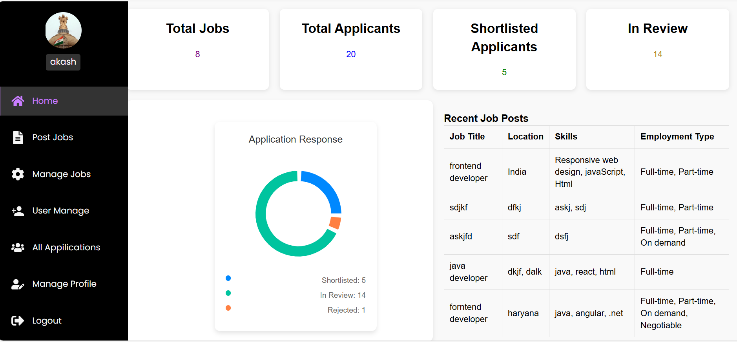

**New job posting**

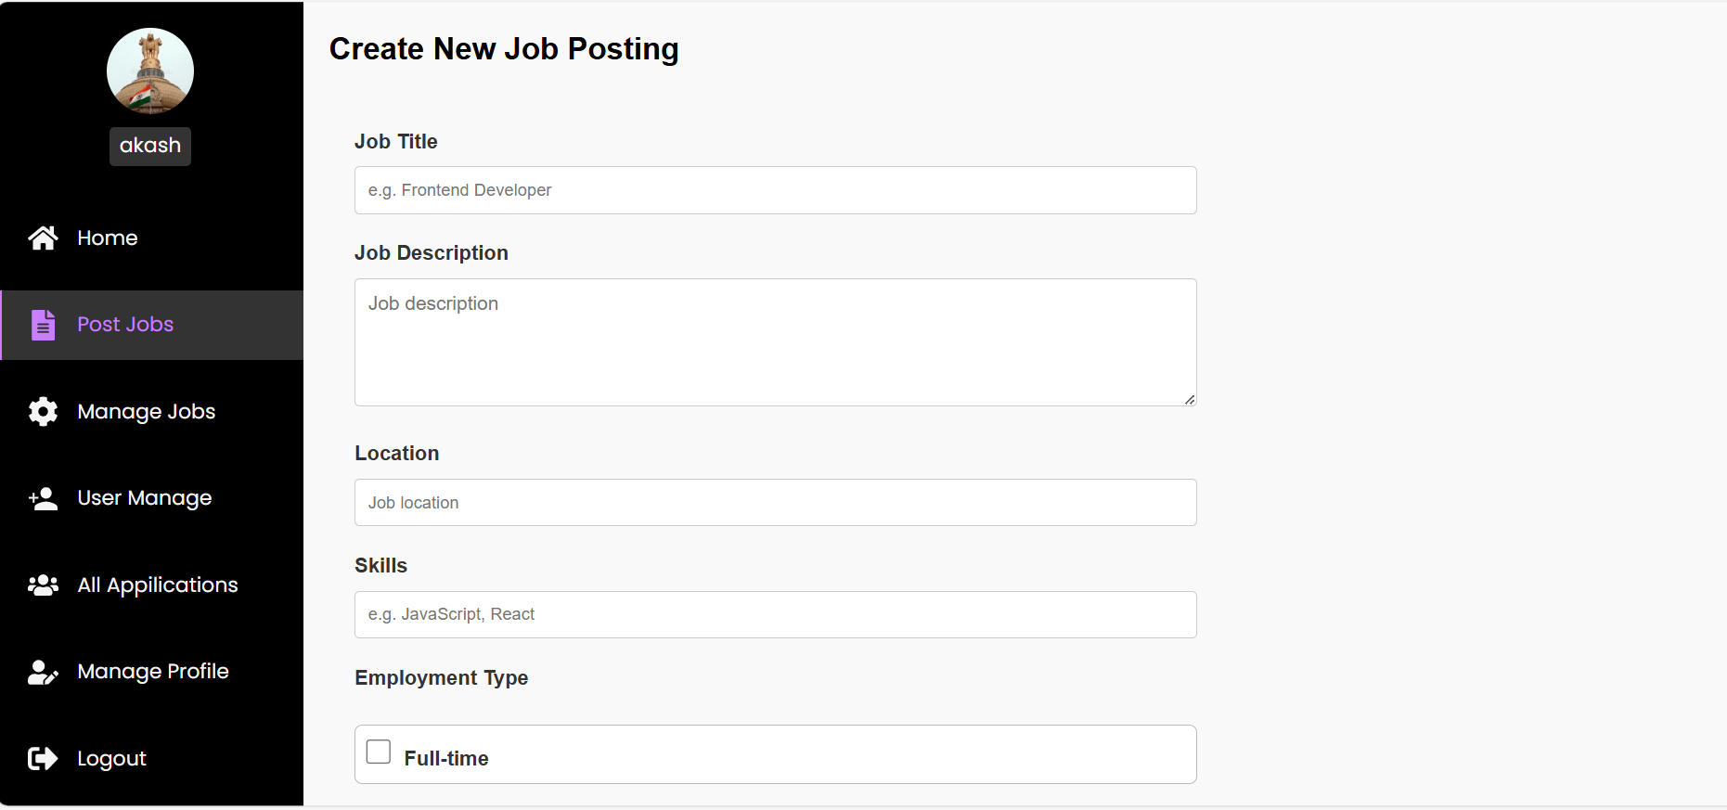

**Manage job postings by updating and deleting jobs**

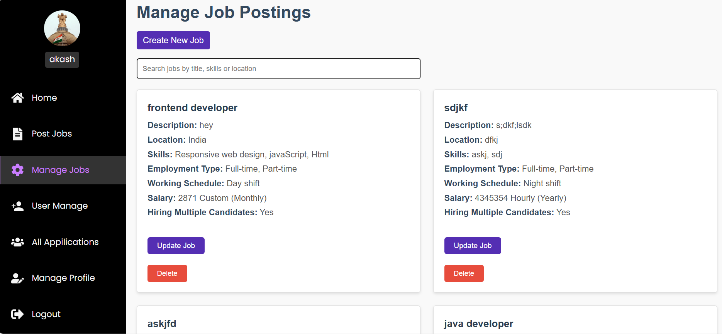

**User management in providing access**

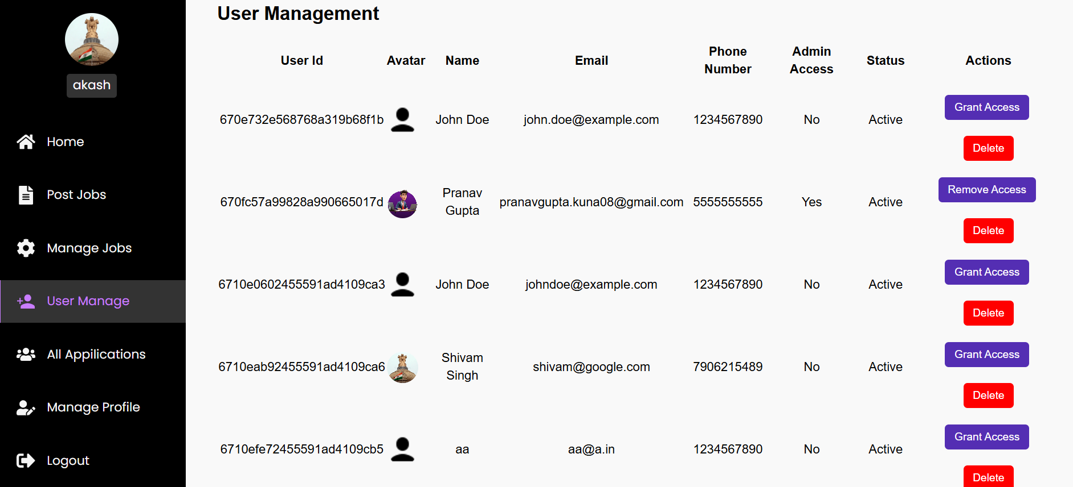

**Application and status of applicants**

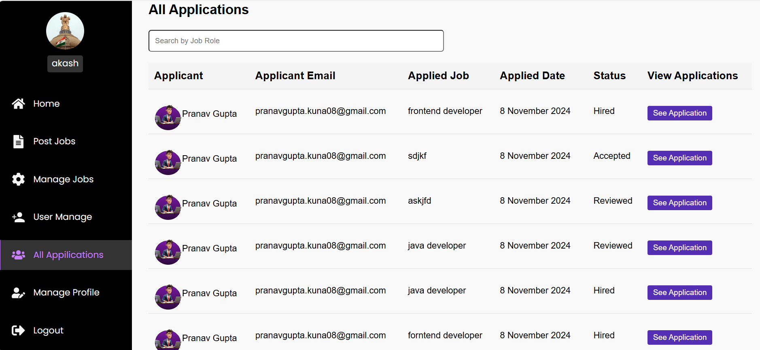

**Admin profile updation**

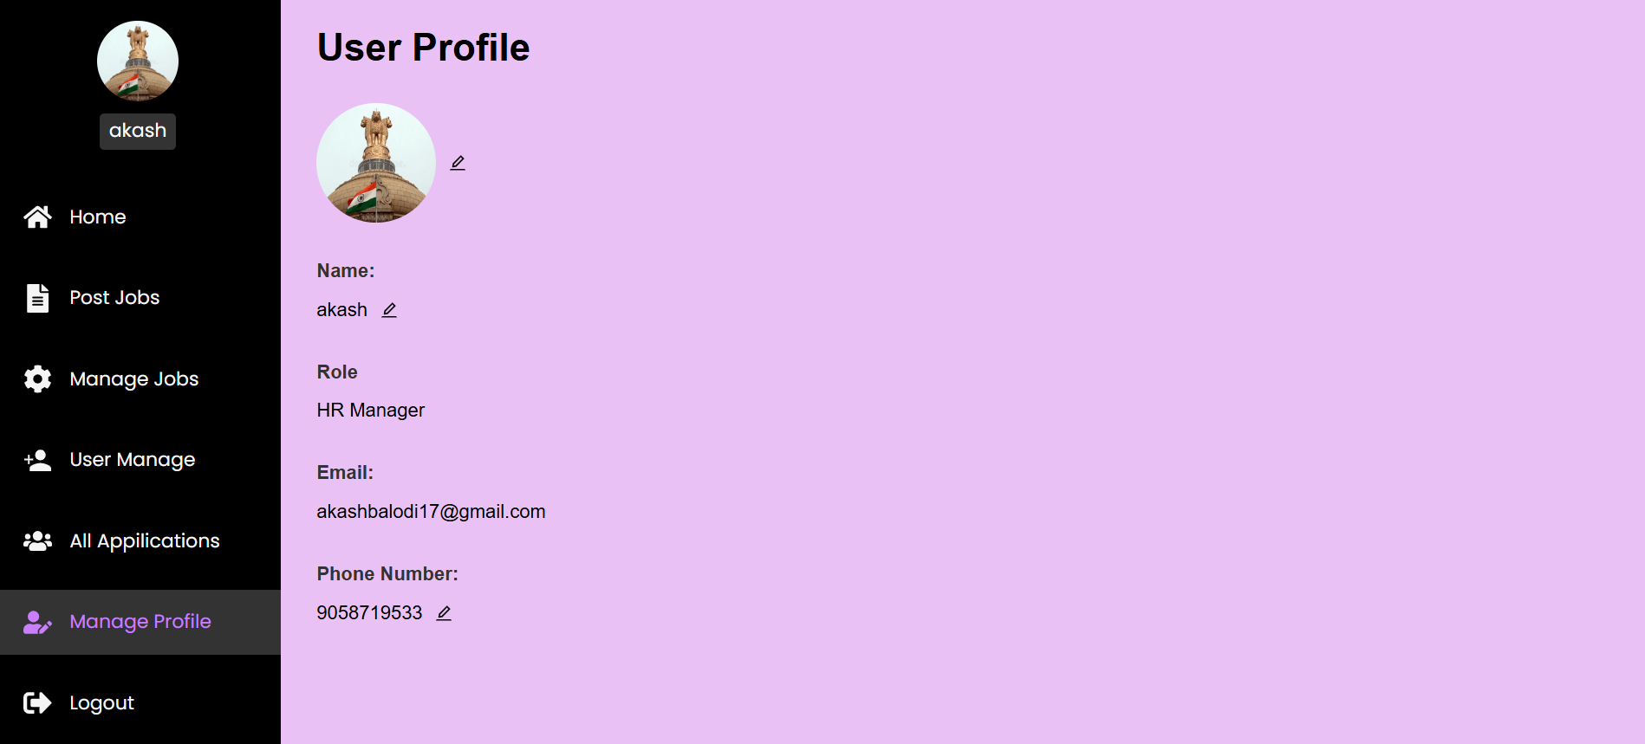

**User interface**

**User dashboard**

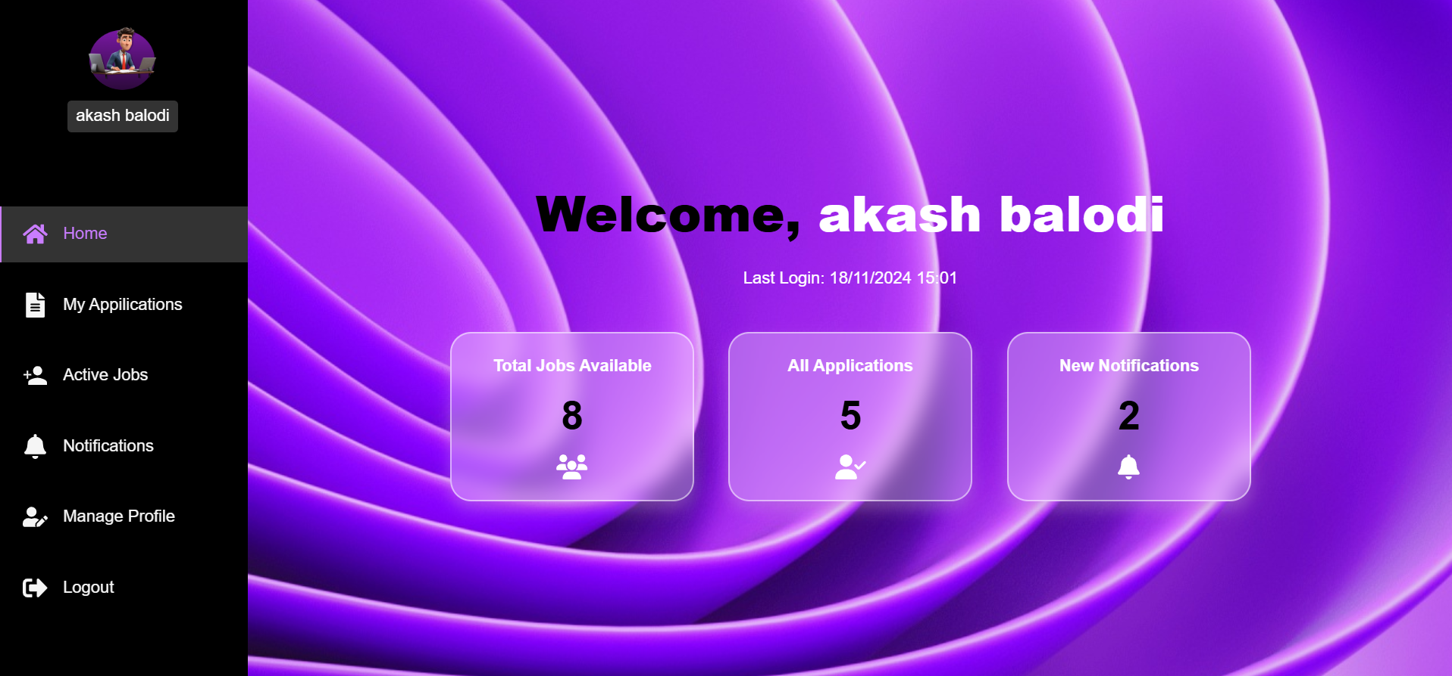

**User job applications**

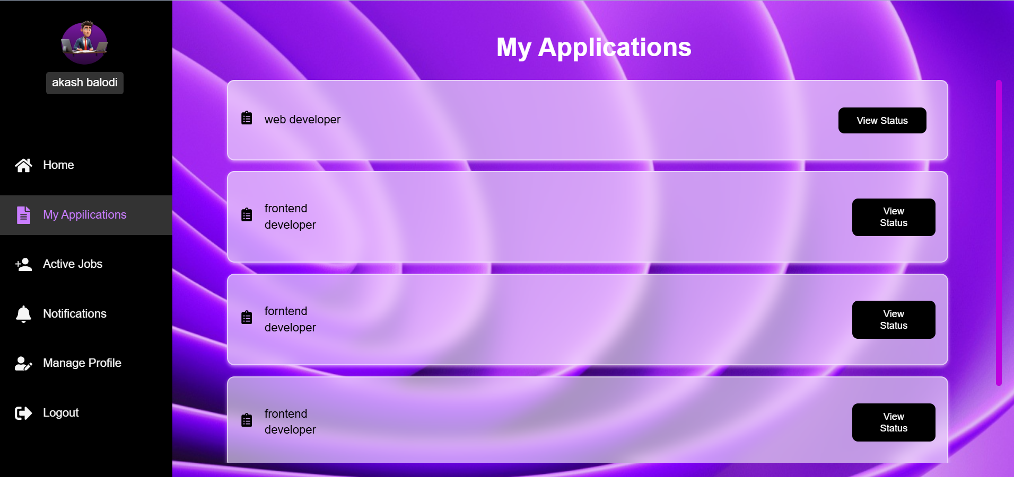

**Job search interface**

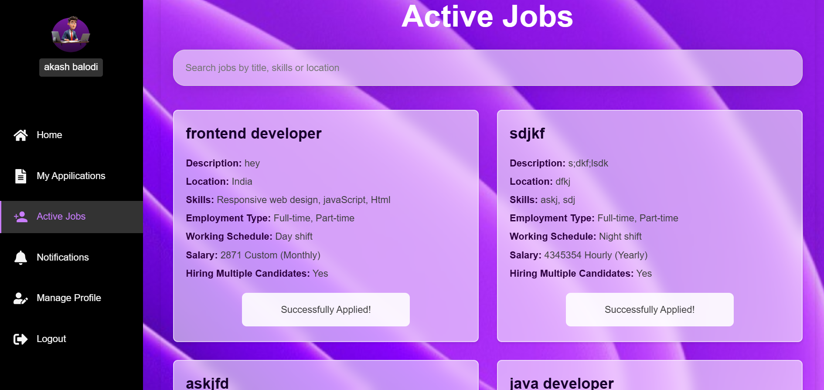

**User notifications on jobs applied**

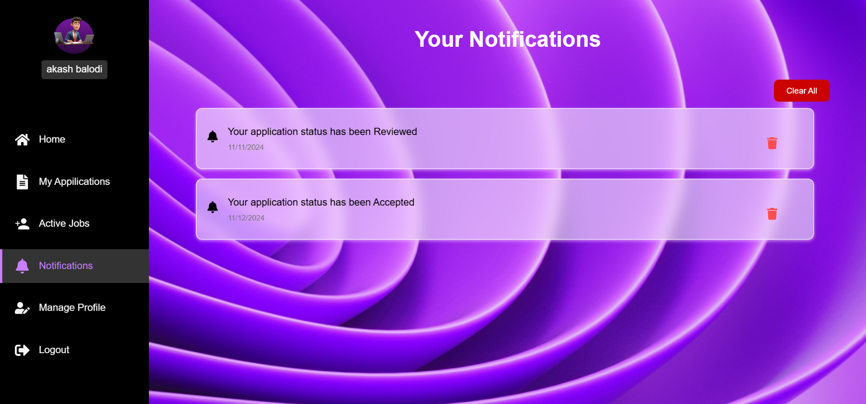

**User profile updation:**

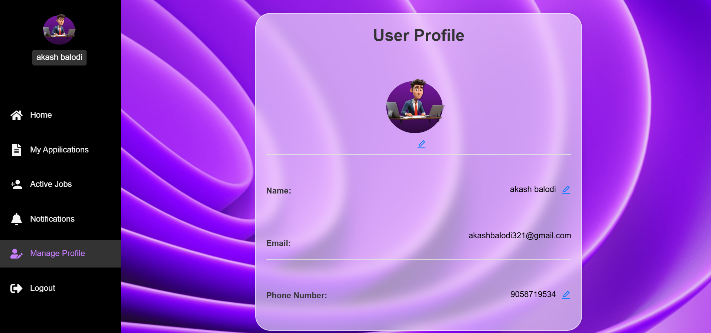

**Login page:**

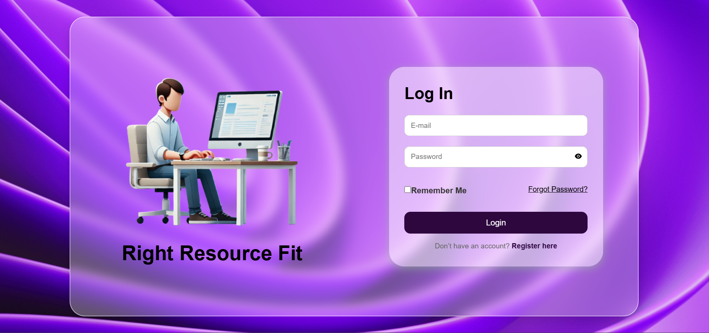

**Register page:**

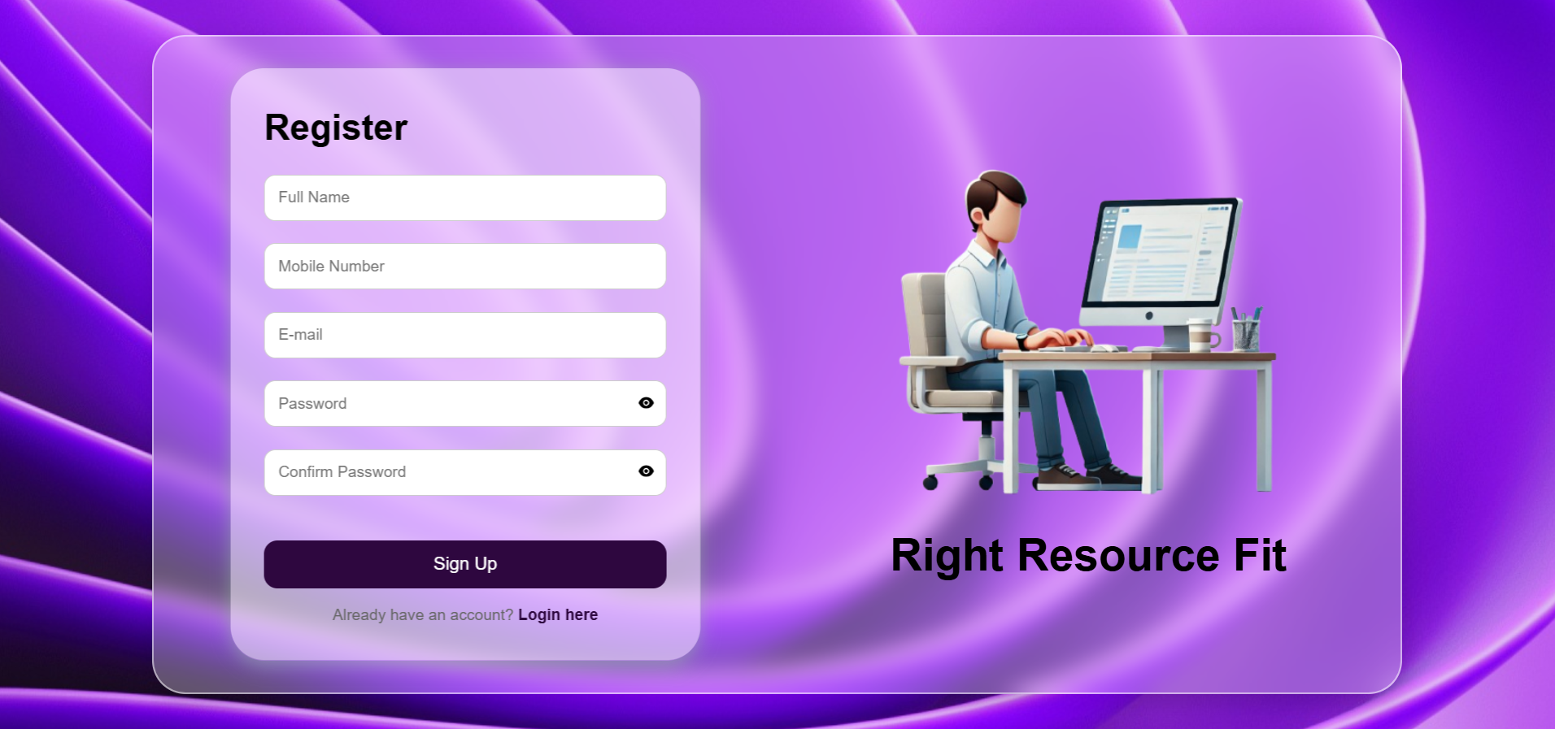

**Home page:**

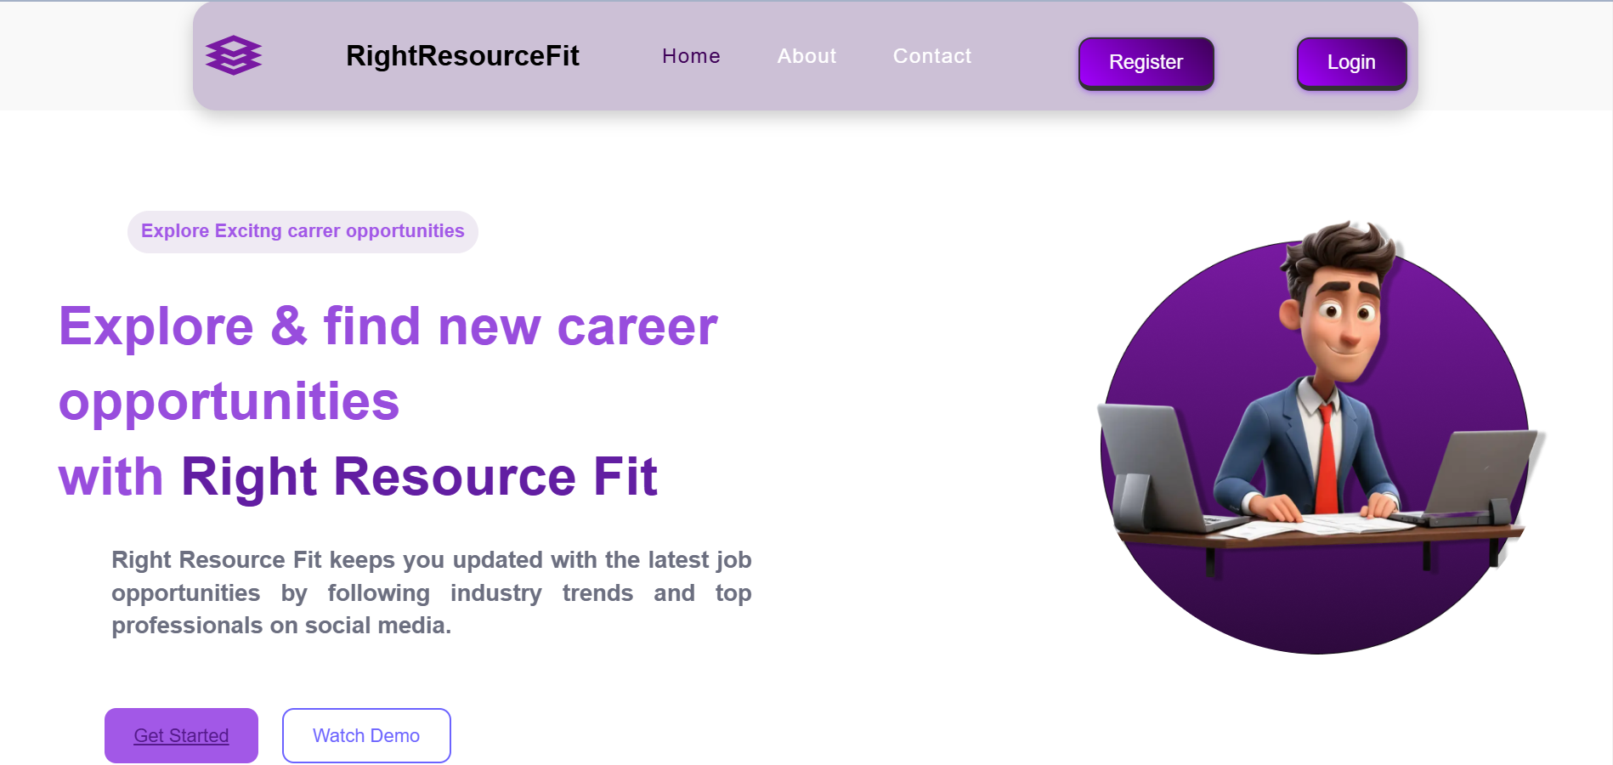

**About page:**

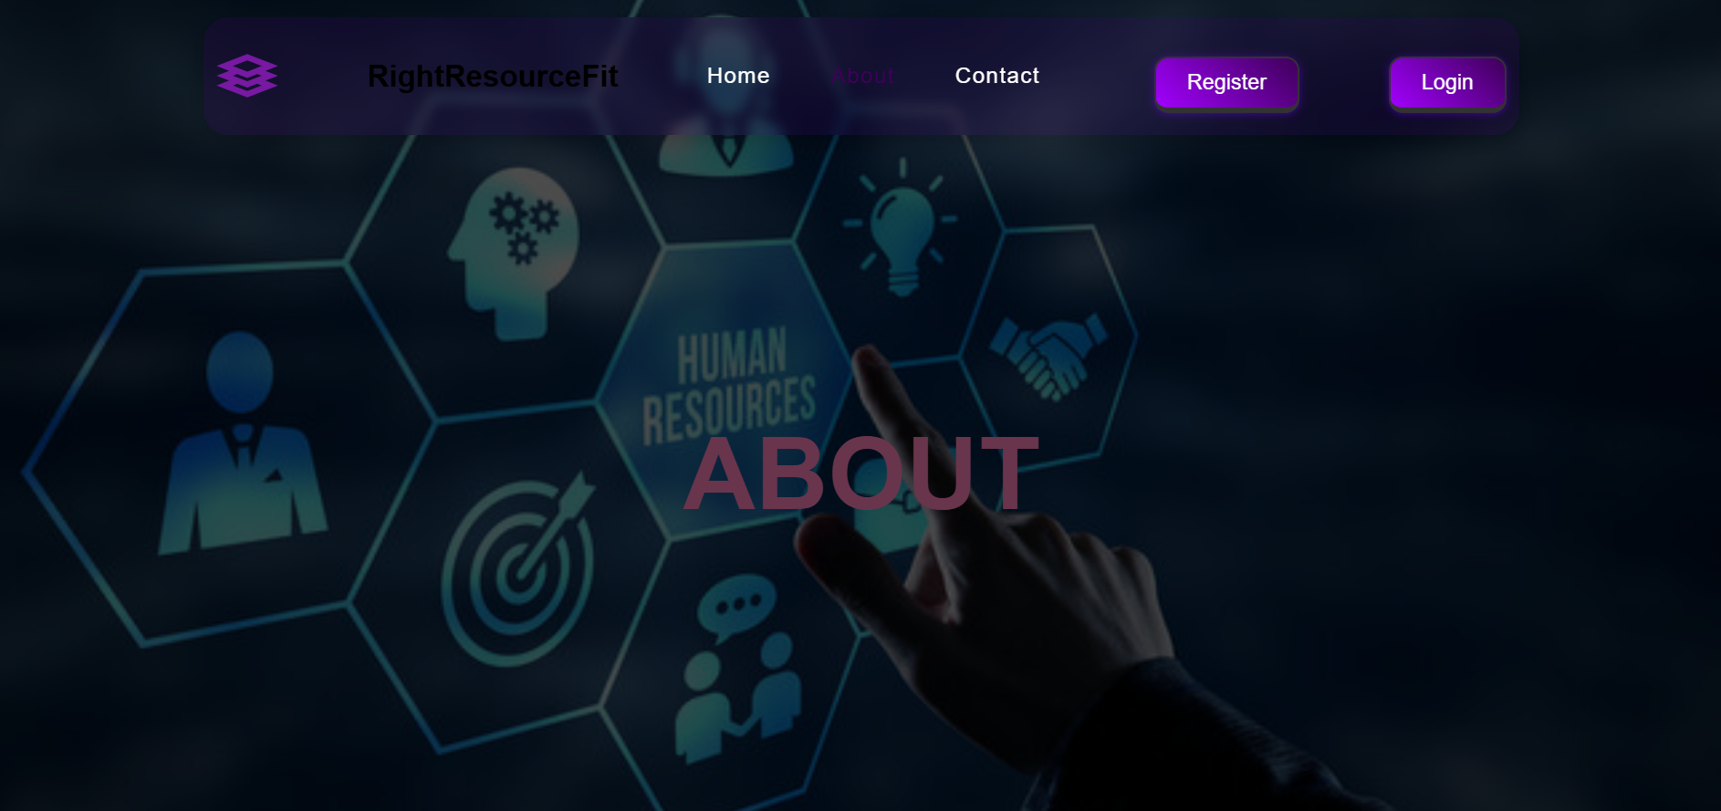

**Contact/Feedback page:**

